ASSIGNMENT-4

DISTANCE DETECTION USING ULTRASONIC SENSOR

|  |  |
| --- | --- |
| Date | 26October 2022 |
| Team ID | PNT2022TMID48 |
| Name | JEMINI S |
| Student Roll Number | 921*5*1910400*5* |
| Maximum Marks | 2 Marks |

Question1 :

Write code and connections in wokwi for ultrasonic sensor. Whenever distance is less than 100 cms send "alert" to ibm cloud and display in device recent events.

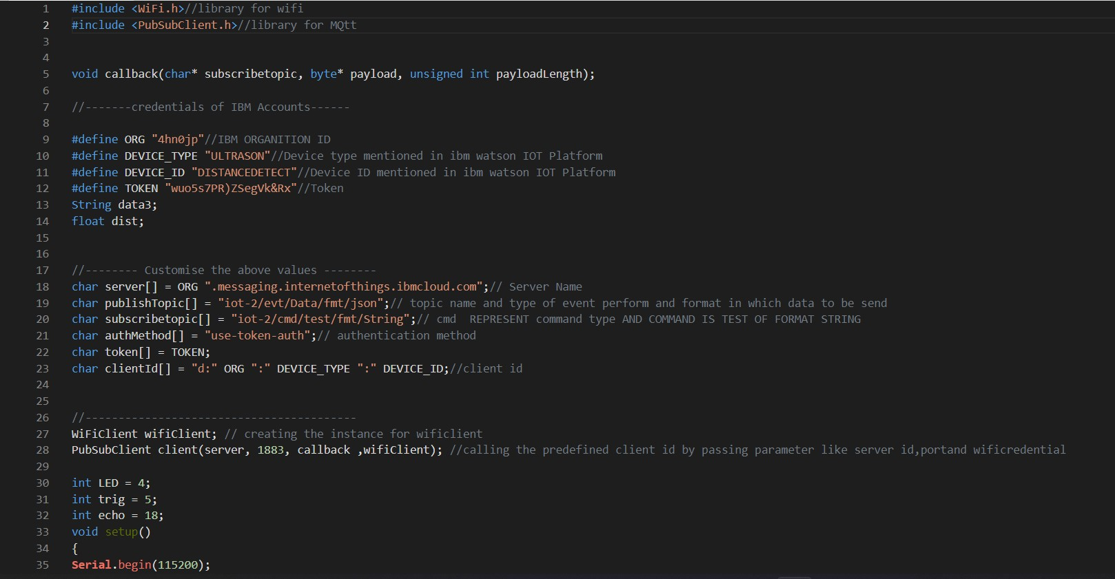CODE :

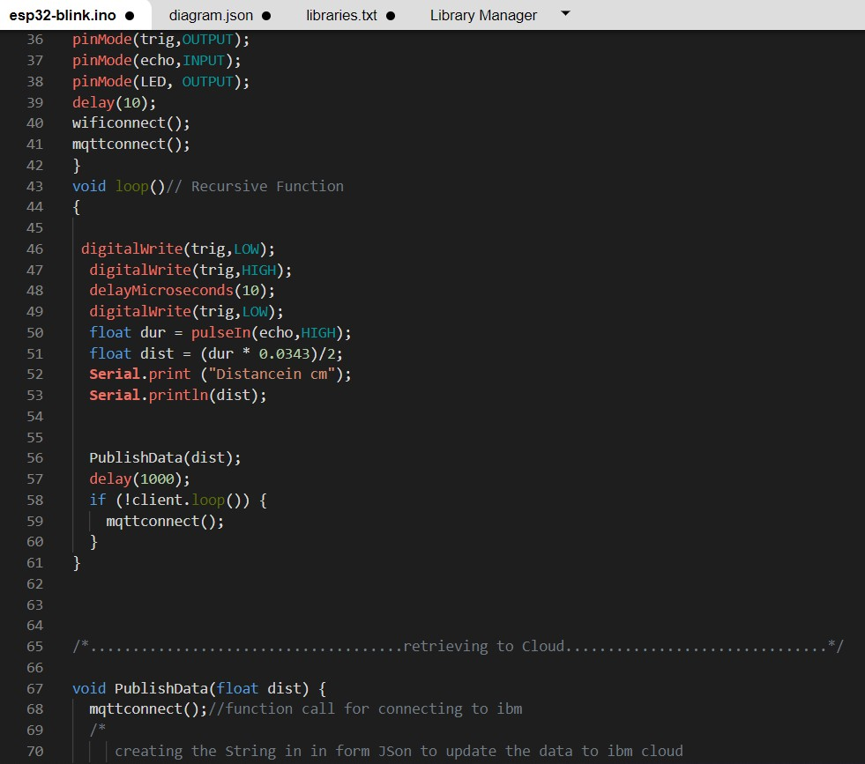

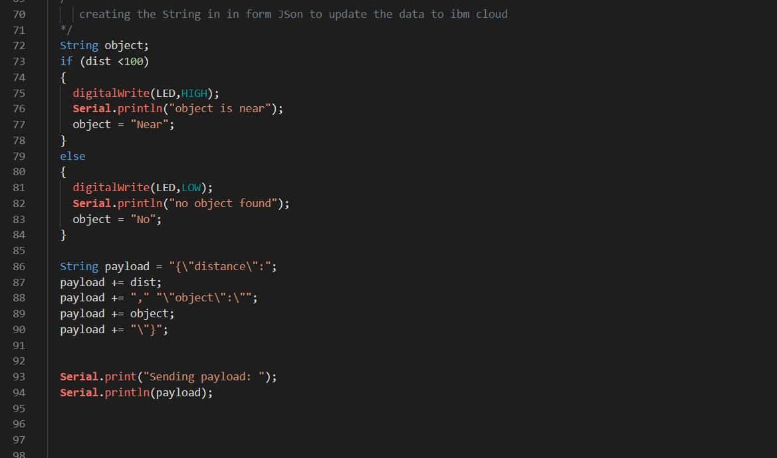

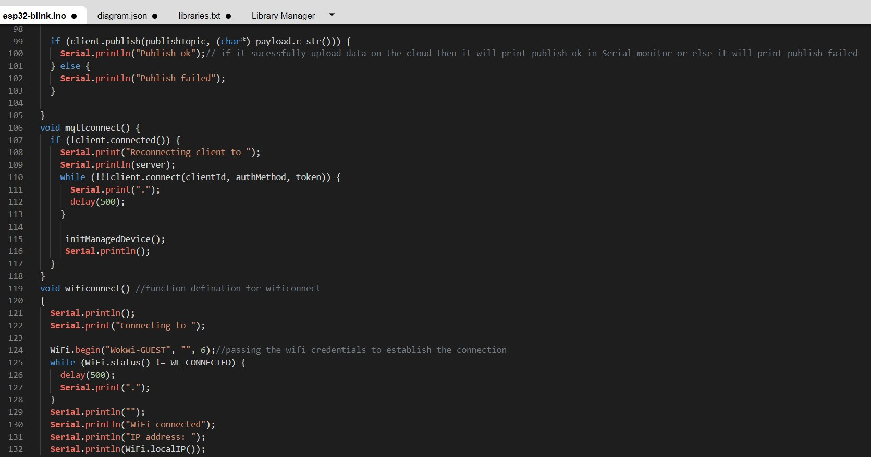

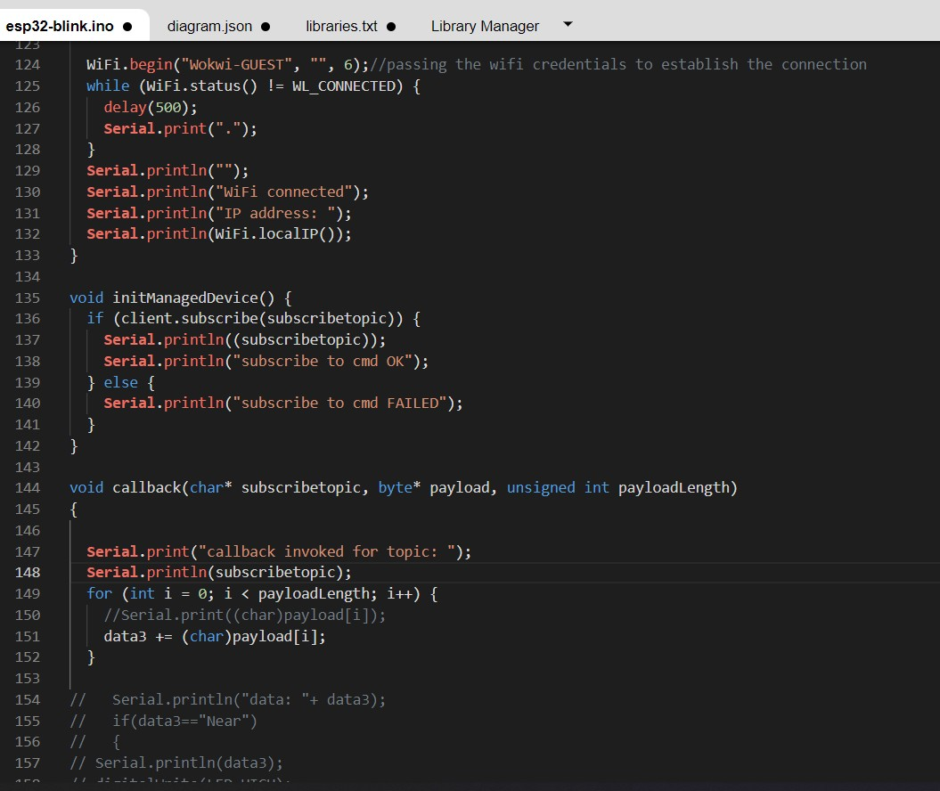

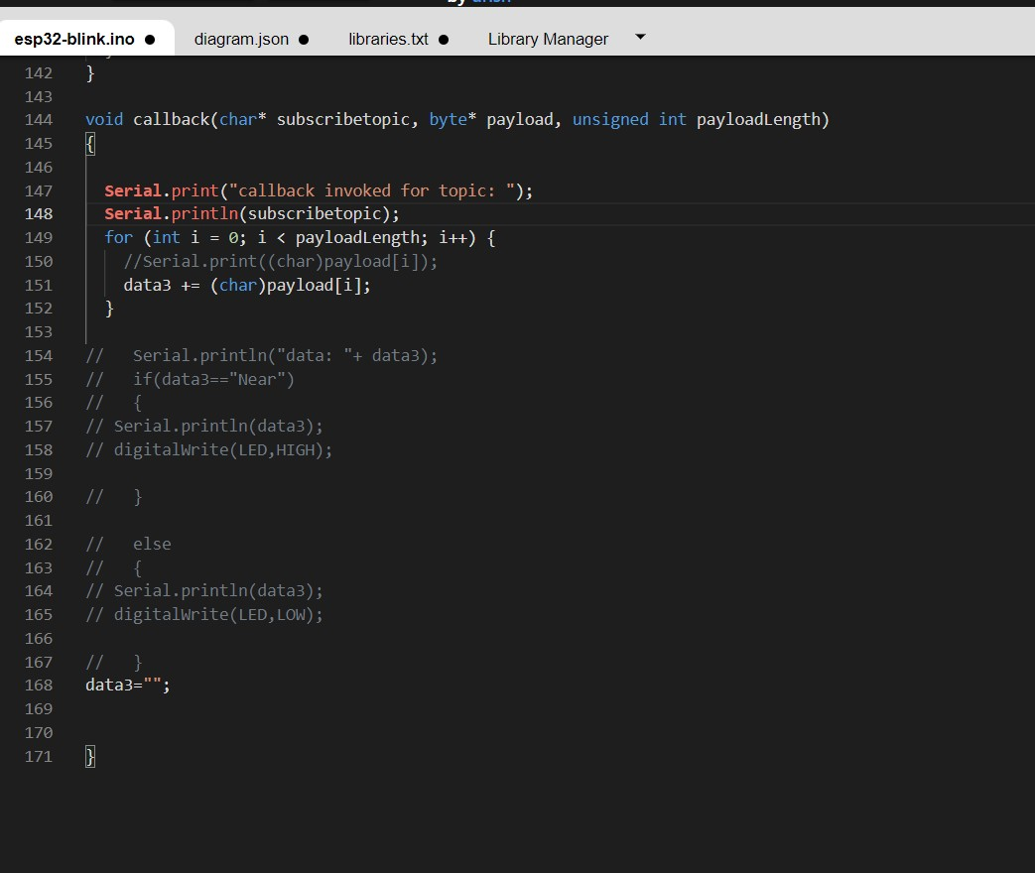

OUTPUT:

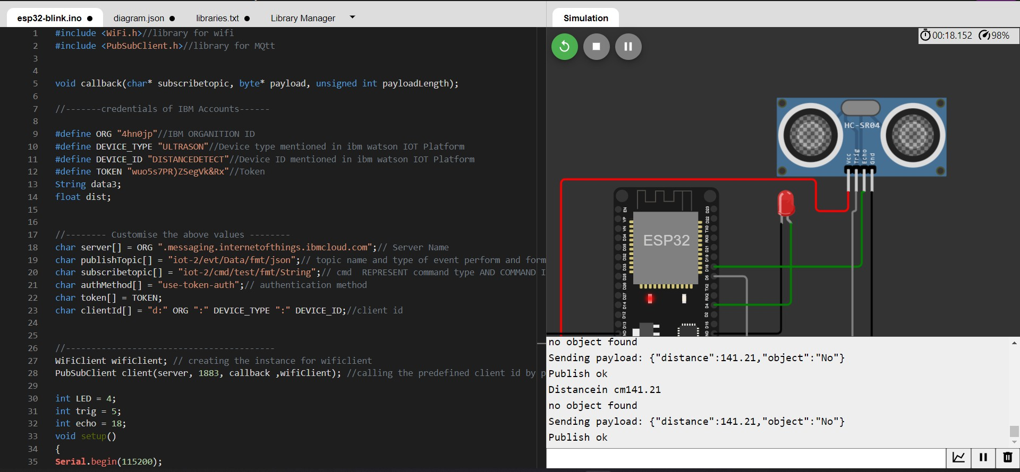

Data send to the IBM cloud device when the object is far

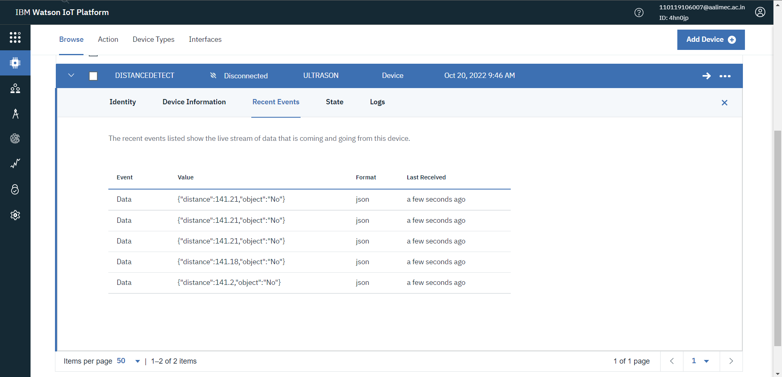

when object is near to the ultrasonic sensor

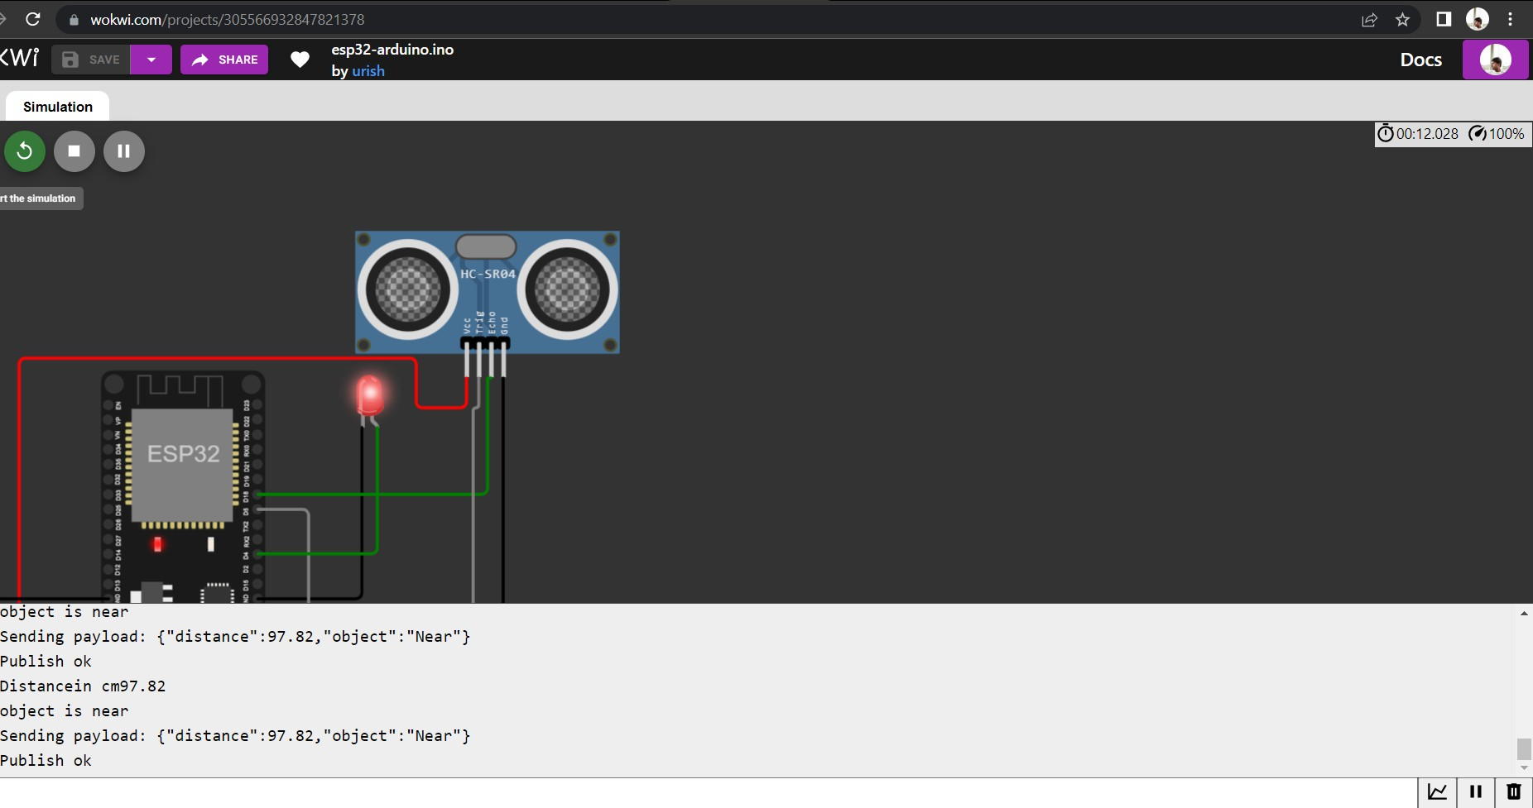

Data sent to the IBM Cloud Device when the object is near

